



ML Ops & Containerization
LAB MANUAL

Disclaimer: The content is curated from online/offline resources and used for educational purpose only
Undoing Changes Using Git – Library Book Inventory
Objective
To understand how Git restores previous versions of files and discards unwanted changes.
Problem Statement
A developer is creating a Library Book Inventory System. While adding new features, some incorrect code is introduced. The developer needs Git to restore the previous working version without losing the project history.
Requirements
Software
- Git
- VS Code
Files
- library.py
- README.md
Procedure
Step 1: Create Project
mkdir LibraryInventory
cd LibraryInventory
git init
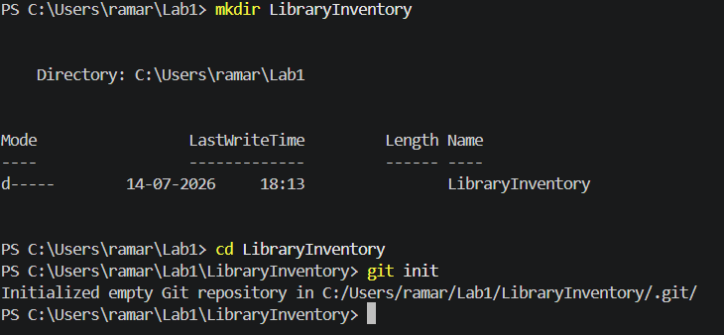
Step 2: Create library.py
books = ["Python","Java","C++"]
print(books)

Step 3: Commit Initial Version
git add .
git commit -m "Initial Library Inventory"
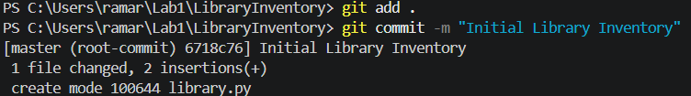
Step 4: Modify Code
Modify the library.py
books = ["Python","Java","C++"]
books.remove("Java")
print(books)

And save the file.
Step 5: View Changes
git diff
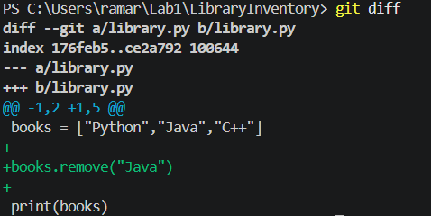

Step 6: Discard Changes
git restore library.py
Step 7: Verify Restoration
Open library.py
The removed code should be restored.
books = ["Python","Java","C++"]
print(books)

Step 8: Add New Feature
books.append("Machine Learning")
books = ["Python","Java","C++"]
books.append("Machine Learning")
print(books)

Step 9: Commit Changes
git add .
git commit -m "Added Machine Learning book"
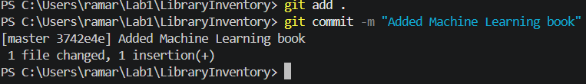
Step 10: View History
git log --oneline
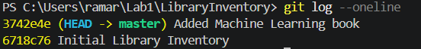
Conclusion
Students learned how Git restores files, removes unwanted modifications, and preserves project history while safely developing software.

